Web Programming

Muhammad Abdullah Ramzan

21F-9204

BSCS

SECTION C

**Task no. 1:**

<!DOCTYPE html>

<html lang="en">

<head>

    <meta charset="UTF-8">

    <meta name="viewport" content="width=<device-width>, initial-scale=1.0">

    <title>Document</title>

</head>

<body>

    <h1>

        First Webpage

    </h1>

    <br>

    <label>

        Muhammad Abdullah Ramzan

        <br>

        21F-9024

        <br>

        Good Question

    </label>

</body>

</html>

**Task no. 2:**

<!DOCTYPE html>

<html lang="en">

<head>

    <meta charset="UTF-8">

    <meta name="viewport" content="width=device-width, initial-scale=1.0">

    <title>Task 2</title>

</head>

<body>

*<!--  bold heading -->*

    <b>

        This heading is bold

    </b>

    <br>

    <strong>

        This heading is strong

    </strong>

    <br>

*<!-- big heading -->*

    <big>

        This heading is big

    </big>

    <br>

*<!-- italic heading -->*

    <i>

        This heading is italic

    </i>

    <br>

    <em>

        This heading is emphasized

    </em>

    <br>

*<!-- small heading -->*

    <small>

        This is computer output

    </small>

    <br>

*<!-- subscript -->*

    <label>

        This is

        <sub>

            subscript

        </sub>

        and

        <sup>

            superscript

        </sup>

    </label>

    <br>

</body>

</html>

**Task no. 3:**

<!DOCTYPE html>

<html lang="en">

<head>

    <meta charset="UTF-8">

    <meta name="viewport" content="width=device-width, initial-scale=1.0">

    <title>Task 3</title>

</head>

<body>

*<!--  image -->*

    <img src="./image.png" alt="Fast Logo" width="500" height="500">

</body>

</html>

**Task no. 4:**

<!DOCTYPE html>

<html lang="en">

<head>

    <meta charset="UTF-8">

    <meta name="viewport" content="width=device-width, initial-scale=1.0">

    <title>Task 3</title>

</head>

<body>

*<!-- open in new tab-->*

    <a href="https://www.nu.edu.pk/" target="_blank">

        <img src="./image.png" alt="Fast Logo" width="500" height="500">

    </a>

</body>

</html>

**Task no. 5:**

<!DOCTYPE html>

<html lang="en">

<head>

    <meta charset="UTF-8">

    <meta name="viewport" content="width=device-width, initial-scale=1.0">

    <title>Task 5a</title>

</head>

<body>

    <h1>

        Unordered list

    </h1>

    <label>

        We have books on a variety of topics, including history:

    </label>

    <ul>

        <li>

            Oracle

        </li>

        <li>

            Java

        </li>

        <li>

            HTML

        </li>

        <li>

            CSS

        </li>

    </ul>

</body>

</html>

<!DOCTYPE html>

<html lang="en">

<head>

    <meta charset="UTF-8">

    <meta name="viewport" content="width=device-width, initial-scale=1.0">

    <title>Task 5b</title>

</head>

<body>

    <h1>

        Ordered list

    </h1>

    <label>

        Follow these steps to install java:

    </label>

    <ol>

        <li>

            Download the software

        </li>

        <li>

            Extract to a folder

        </li>

        <li>

            Double click on the executable to run

        </li>

    </ol>

</body>

</html>

**Task no. 3:**

<!DOCTYPE html>

<html lang="en">

<head>

    <meta charset="UTF-8">

    <meta name="viewport" content="width=device-width, initial-scale=1.0">

    <title>My Page</title>

</head>

<body>

    <table  border="1px" style="border-collapse: collapse;text-align: center;">

        <tr>

            <td rowspan="3"> April</td>

            <td> Lorem, ipsum.</td>

            <td> Lorem, ipsum.</td>

            <td> Lorem, ipsum.</td>

        </tr>

        <TR>

            <td> Lorem, ipsum.</td>

            <td> Lorem, ipsum.</td>

            <td> Lorem, ipsum.</td>

      </tr>

      <tr>

          <td> Lorem, ipsum.</td>

         <td> Lorem, ipsum.</td>

         <td> Lorem, ipsum.</td>

        </tr>

        <tr>

        <td> Lorem, ipsum.</td>

        <td>Lorem, ipsum.</td>

        <td> Lorem, ipsum.</td>

        <td> Lorem, ipsum.</td>

        </tr>

    </table>

</body>

</html>

**Task no. 3:**

<!DOCTYPE html>

<html lang="en">

<head>

    <meta charset="UTF-8">

    <meta name="viewport" content="width=device-width, initial-scale=1.0">

    <title>My Page</title>

</head>

<body>

    <table  border="1px" style="border-collapse: collapse;text-align: center;">

        <tr>

            <td colspan="3"> 2022</td>

        </tr>

        <TR>

            <td> Lorem, ipsum.</td>

            <td> Lorem, ipsum.</td>

            <td> Lorem, ipsum.</td>

        </tr>

        <tr>

            <td colspan="2" rowspan="2"> Fiesta </td>

            <td> Lorem, ipsum.</td>

        </tr>

        <tr>

            <td> Lorem, ipsum.</td>

        </tr>

        <TR>

            <td> Lorem, ipsum.</td>

            <td> Lorem, ipsum.</td>

            <td> Lorem, ipsum.</td>

        </tr>

    </table>

</body>

</html>

**Task no. 3:**

<!DOCTYPE html>

<html lang="en">

<head>

    <meta charset="UTF-8">

    <meta name="viewport" content="width=device-width, initial-scale=1.0">

    <title>TAsk 8</title>

</head>

<body>

        <form>

            <label >Username:</label>

            <input type="text" name="username" id="username" required>

            <br>

            <br>

            <label>

                Email:

            </label>

            <input type="email" name="email" id="email" required>

            <br>

            <br>

            <label>

                Password:

            </label>

            <input type="password" name="password" id="password" required><br><br>

            <label>

                Confirm Password:

            </label>

            <input type="password" name="confirm_password" id="confirm_password" required><br><br>

            <input type="submit" value="Submit">

            <input type="reset" value="Reset">

</body>

</html>

**Task no. 3:**

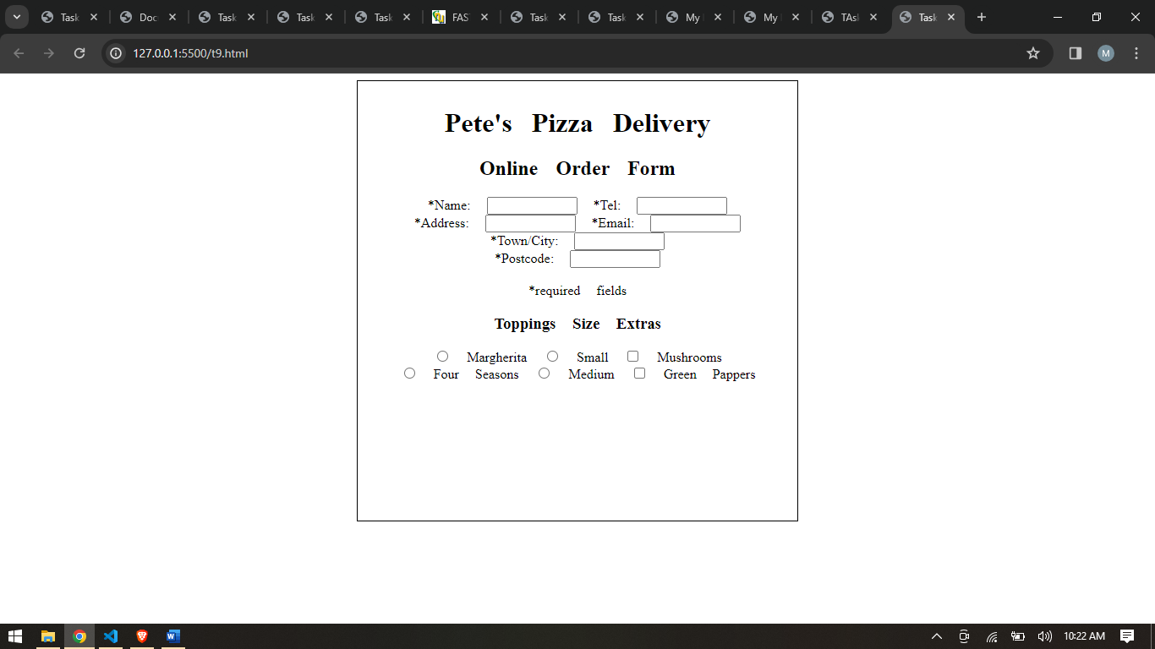

<!DOCTYPE html>

<html lang="en">

<head>

    <meta charset="UTF-8">

    <meta name="viewport" content="width=device-width, initial-scale=1.0">

    <title>Task 9</title>

    <style>

        #div1{

            width: 500px;

            height: 500px;

            margin: auto;

            text-align: center;

            border: 1px solid black;

            padding: 10px;

            word-spacing: 15px;

        }

        #town{

        }

    </style>

</head>

<body>

    <div id="div1">

        <h1 >

            Pete's Pizza Delivery

        </h1>

        <h2 text>

            Online Order Form

        </h2>

        <label>

            *Name:

        </label>

        <input type="text" name="name" id="name" size="10px"  required>

        <label>

        </label>

        <label>

            *Tel:

        </label>

        <input type="text" name="tel" id="tel" size="10px" required>

        <br>

        <label>

            *Address:

        </label>

        <input type="text" name="address" id="address" size="10px" required>

        <label>

            *Email:

        </label>

        <input type="email" name="email" id="email" size="10px" required>

        <br>

        <label>

            *Town/City:

        </label>

        <input type="text" name="town" id="town" size="10px" required>

        <br>

        <label>

            *Postcode:

        </label>

        <input type="text" name="postcode" id="postcode" size="10px" required>

        <br>

        <br>

        <label>

            *required fields

        </label>

        <div>

            <h3>

                Toppings                                                               Size                                                                                   Extras

            </h3>

            <label>

                <input type="radio" name="toppings" id="toppings" value="Pepperoni">

                Margherita

            </label>

            <label>

                <input type="radio" name="toppings" id="toppings" value="Mushrooms">

                Small

            </label>

            <label>

                <input type="checkbox" name="toppings" id="toppings" value="Onions">

                Mushrooms

            </label>

            <br>

            <label>

                <input type="radio" name="toppings" id="toppings" value="Pepperoni">

                Four Seasons

            </label>

            <label>

                <input type="radio" name="toppings" id="toppings" value="Mushrooms">

                Medium

            </label>

            <label>

                <input type="checkbox" name="toppings" id="toppings" value="Onions">

                Green Pappers

            </label>

        </div>

    </div>

</body>

</html>